DML Commands with Constraints –UPDATE, DELETE

Questions:
- Update the value of student name whose register number is ‘191711342’
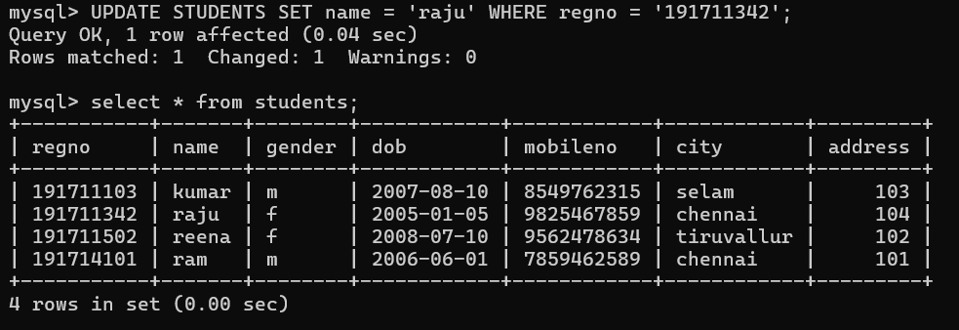

- Delete the record in the table FACULTY, who resigned her job.

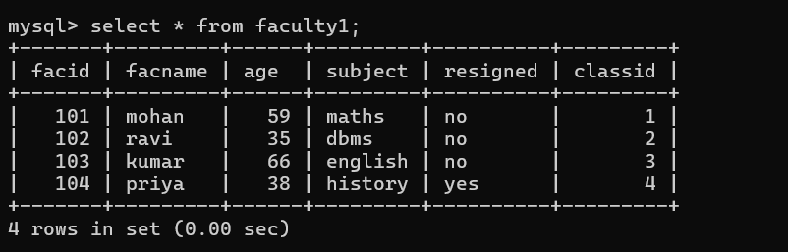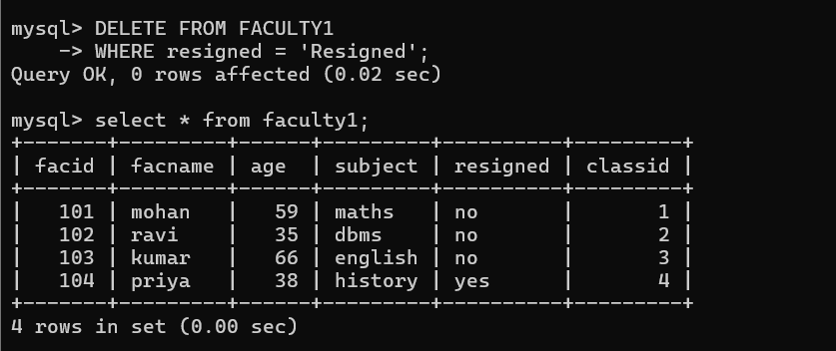
3.Modify the age for the faculty whose name is 'mohan' with a value ‘59’.
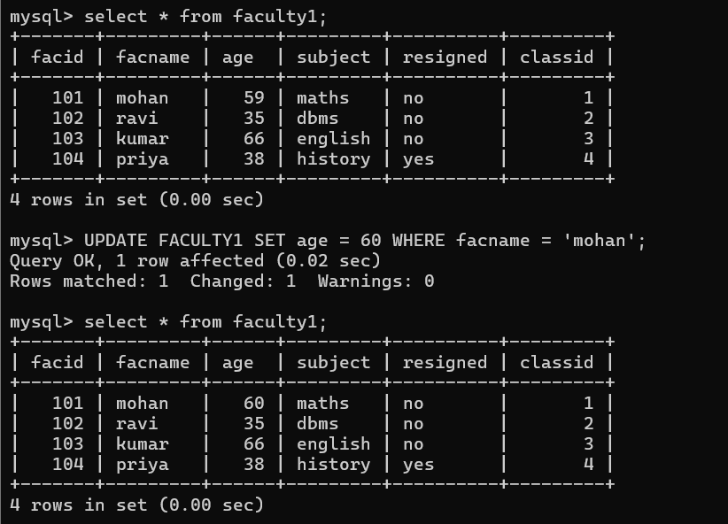
4.Remove all faculty who are having over 65 years
